SUMMER DAYS OUT 2018
White Stubbs Lane
Broxbourne
Hertfordshire
EN10 7QA
ENTRY Fees: Disable include carer: Gate price £ 16.50

17th August 2018 1000 hrs
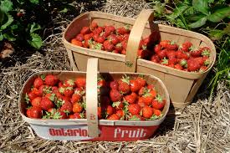 | STRAWBERRY PICKING  22nd June 2018 1000 hrs  29th June 2018 1000 hrs

SUMMER DAYS OUT 2018
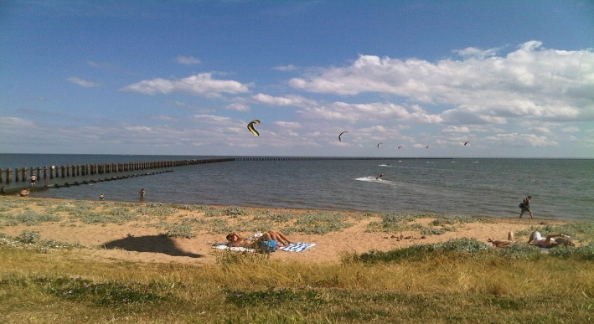 | SHOEBURYNESS BEACH  13th July 2018 1000 hrs  20th July 2018 1000 hrs
Grahame Park Way,
London
NW9 5LL
9th August 2018 1000 hrs
10th August 2018 1000 hrs

Free admission
SUMMER DAYS OUT 2018
CREWS HILL GARDEN CENTER
CREWS HILL
Admissions free

28th August 2018 1000 hrs
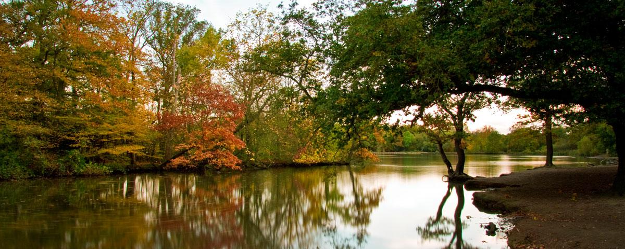 | EPPING FOREST  THE WARREN  LOUGHTON -  IG10 4RW  24th August 2018 1000 hrs  Free admission

SUMMER DAYS OUT 2018
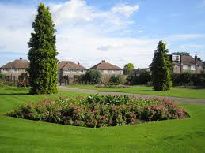 | CEDARS PARK  WALTHAM CROSS  EN8 8RN  27th July 2018 1000 hrs  6th August 2018 1000 hrs  Free admission
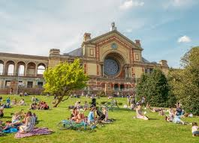 | ALEXANDRA PALACE  ALEXANDRA PALACE WAY  LONDON - N22 7AY  15th June 2018 1000 hrs  20th August 2018 1000 hrs  Free admission
SUMMER DAYS OUT 2018
FORTY HALL FARM
ENFIELD - EN2 9HA
TEL 0208363 1393 ( Tuesday & Thursday afternoon only)

21th August 2018 1000 hrs
23rd August 2018 1000 hrs
Entry fee £2

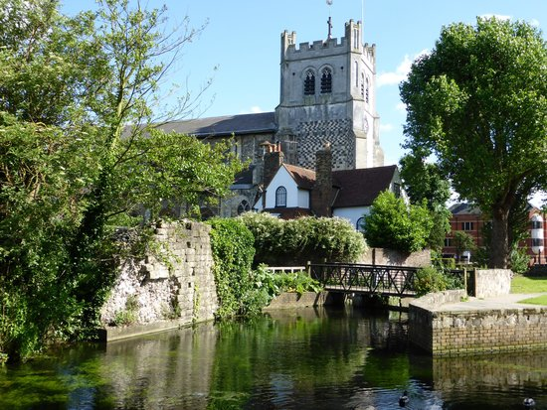 | WALTHAM ABBEY GARDEN  WALTHAM ABBEY - EN9 1XQ  31st August 2018 1000 hrs  Free admission

SUMMER DAYS OUT 2018
LEE VALLEY WHITEWATER CENTRE
STATION ROAD
WALTHAM CROSS - EN9 1AB
TEL 03000 030 616
(Call for group booking)

16th August 2018 1000 hrs

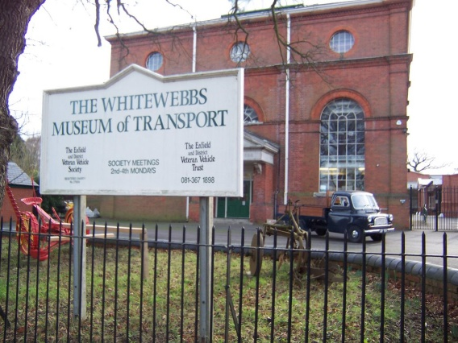 | WHITEWEBBS MUSEUM OF TRANSPORT  ENFIELD - EN2 9HW  TEL 0208 367 1898  Open Tuesday from 1000 hrs - 1600hrs  Fee £5 per adult  14th August 2018 1000 hrs  Fee £5 per adult

SUMMER DAYS OUT 2018
WILLOWS ACTIVITY FARM
COURSERS ROAD
ST ALBAN - AL4 0PF
TEL 0870 129 9718
15 August 2018 1000 hrs
ENTRANCE FEE £14.50

WOBURN SAFARI PARK
WOBURN RIDGMONT
MILTON KEYNES - MK17 9QN
TEL 01525 290407
22nd August 2018 @ 1000 hrs

Fees: call for group booking

